**PROJECT NAME:**

**PLUGGING INTO THE FUTURE: AN EXPLORATION OF ELECTRICITY CONSUMPTION PATTERNS**

**TEAM MEMBERS:**

**1.Aysha M**

**2.Suwetha R**

**3.Sneha R**

**4.Sathya M**

Project Report

**1.INTRODUCTION**

**1.1 Overview**

India is the world's third-largest producer and third-largest consumer of electricity. The national electric grid in India has an installed capacity of 370.106 GW as of 31 March 2020. Renewable power plants, which also include large hydroelectric plants, constitute 35.86% of India's total installed capacity. During the fiscal year (FY) 2019–20, the total electricity generation in the country was 1,598 TWh, of which 1,383.5 TWh generated by utilities. The gross electricity consumption per capita in FY2019 was 1,208 kWh. In 2015-16, electric energy consumption in agriculture was recorded as being the highest (17.89%) worldwide. The per capita electricity consumption is low compared to most other countries despite India having a low electricity tariff. In light of the recent COVID-19 situation, when everyone has been under lockdown for the months of March to June the impacts of the lockdown on economic activities have been faced by every sector in a positive or a negative way.

**1.2 purpose**

Analyzing Electricity Consumption in India from Jan 2019 till 5 th December 2020. This dataset contains a record of Electricity consumption in each states of India, here we are going to Analyse State wise, Region wise and Overall Electricity consumption in India

**2.PROBLEM DEFINITION&DESIGN THINKING**

**2.1 Empathy map screenchat**

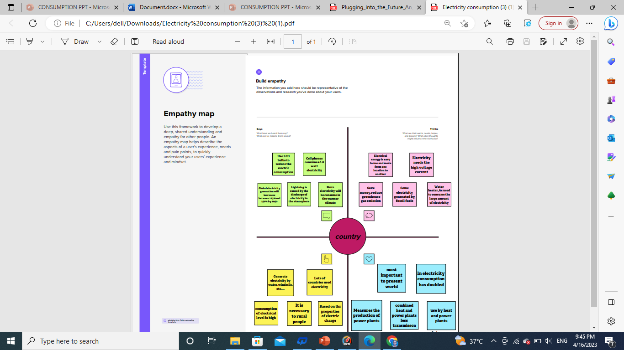

**2.2 Ideation & Brainstorming map screen chat**

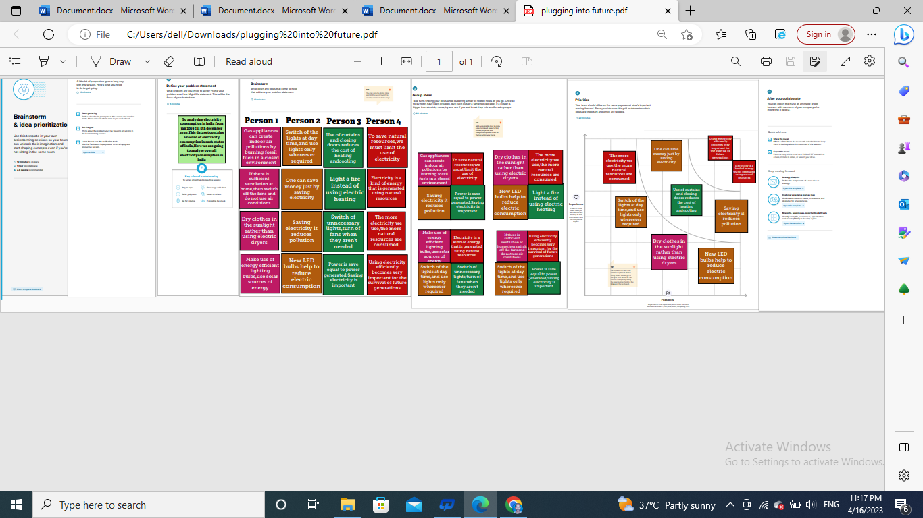

**3.RESULT**

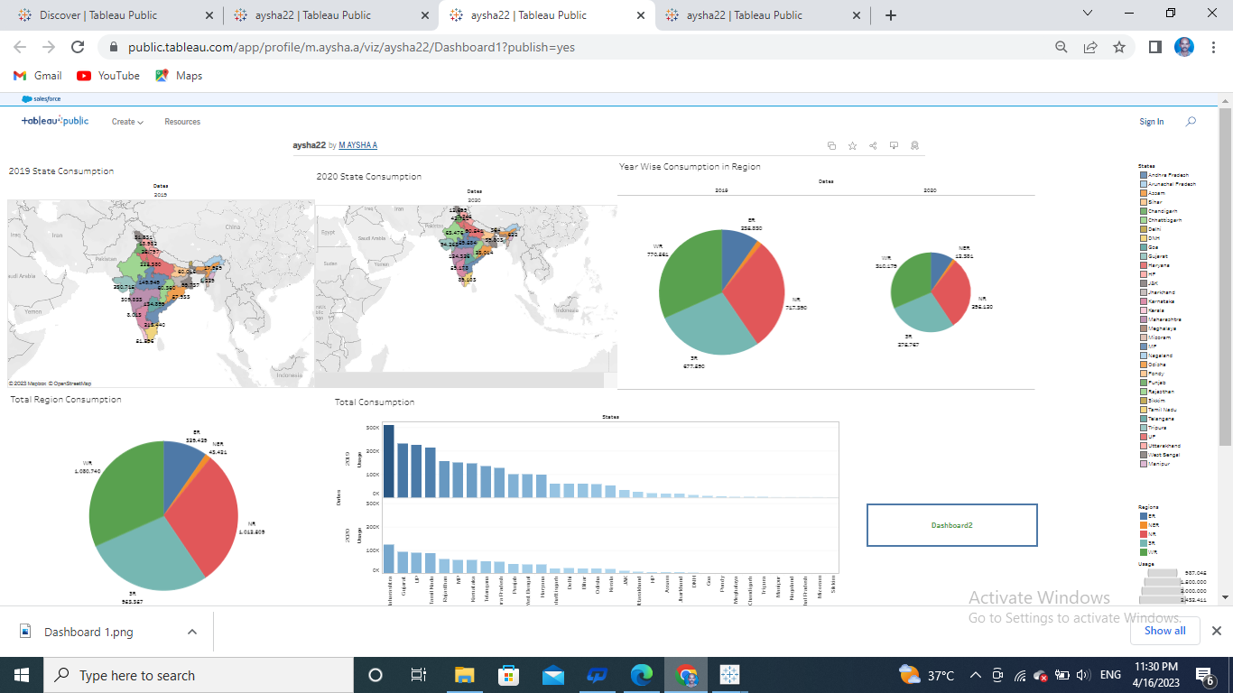

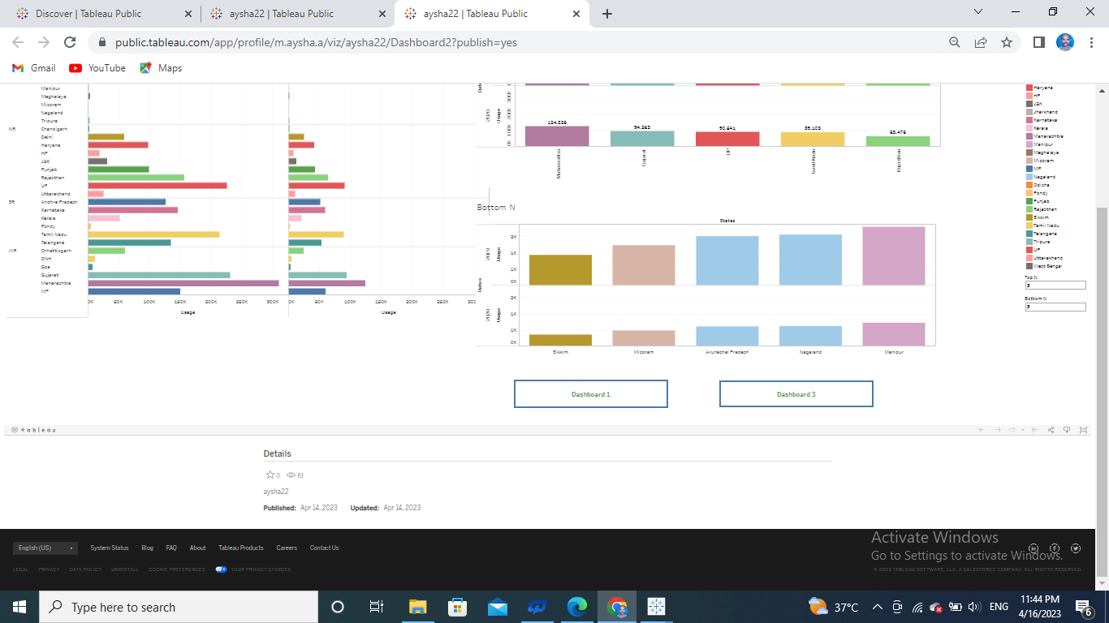

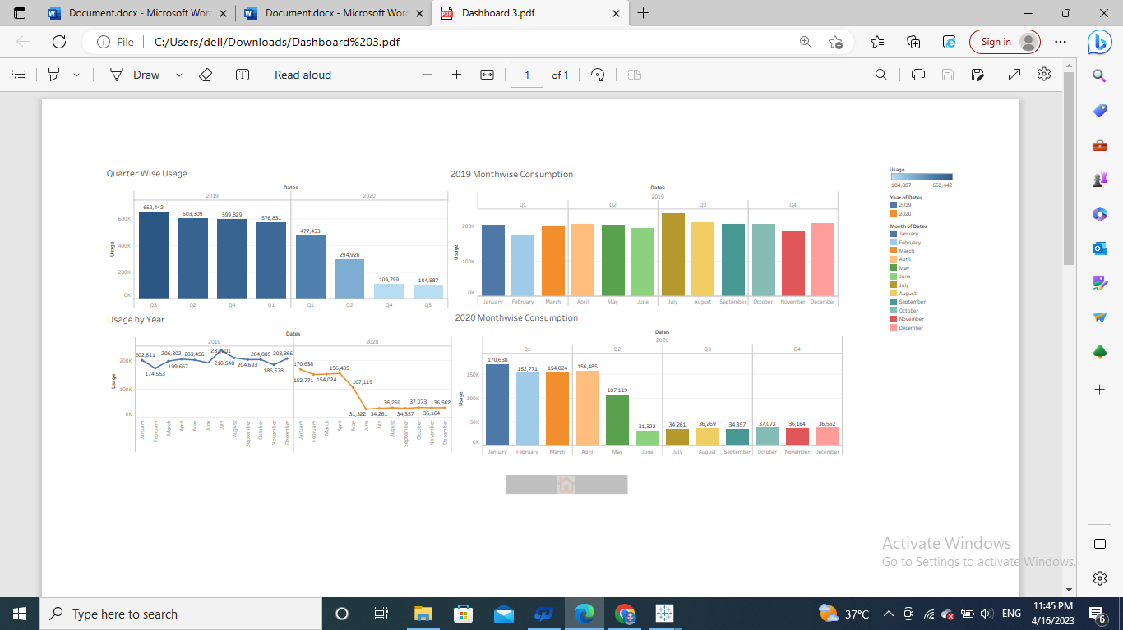

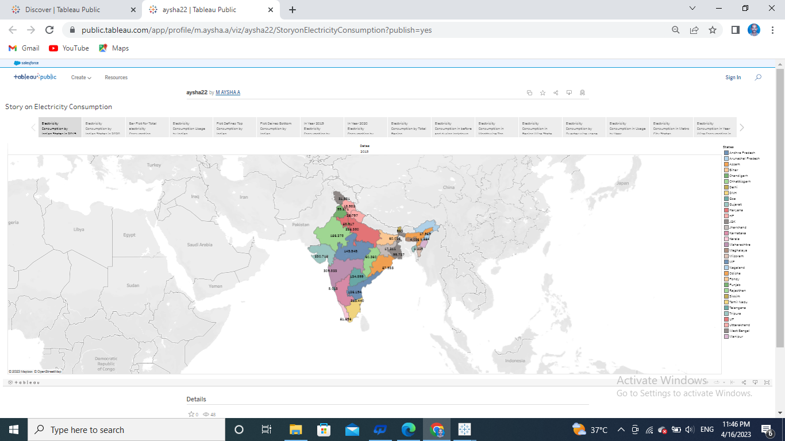

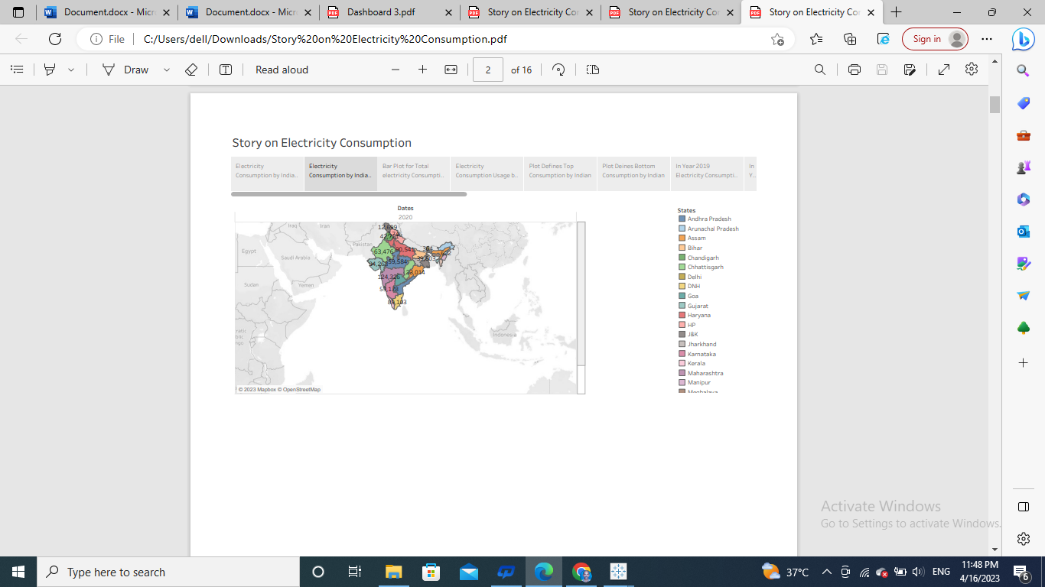

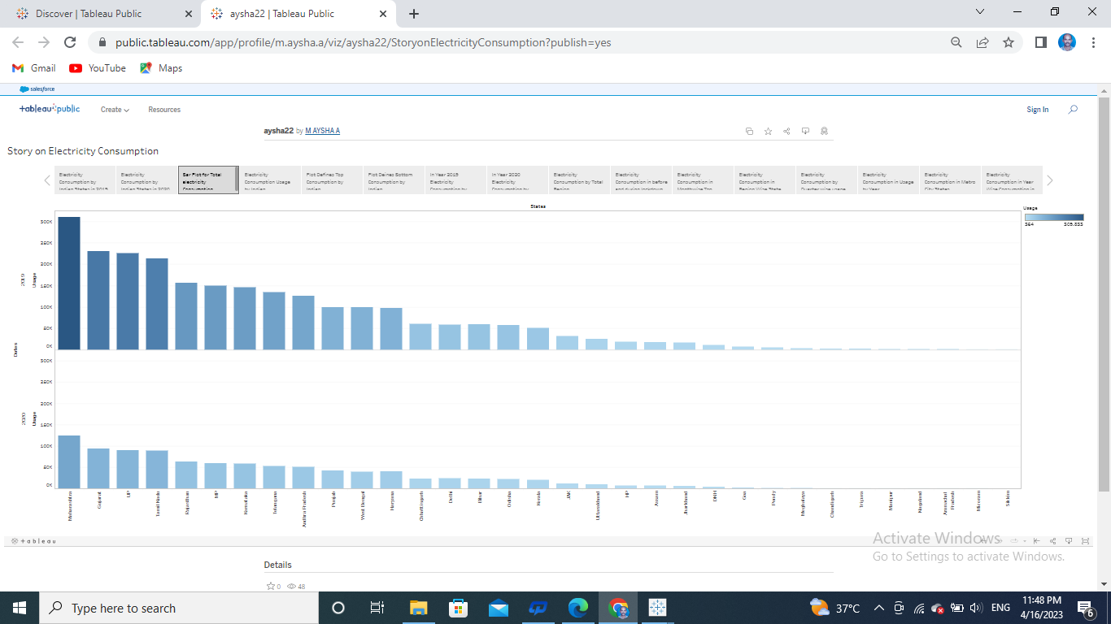

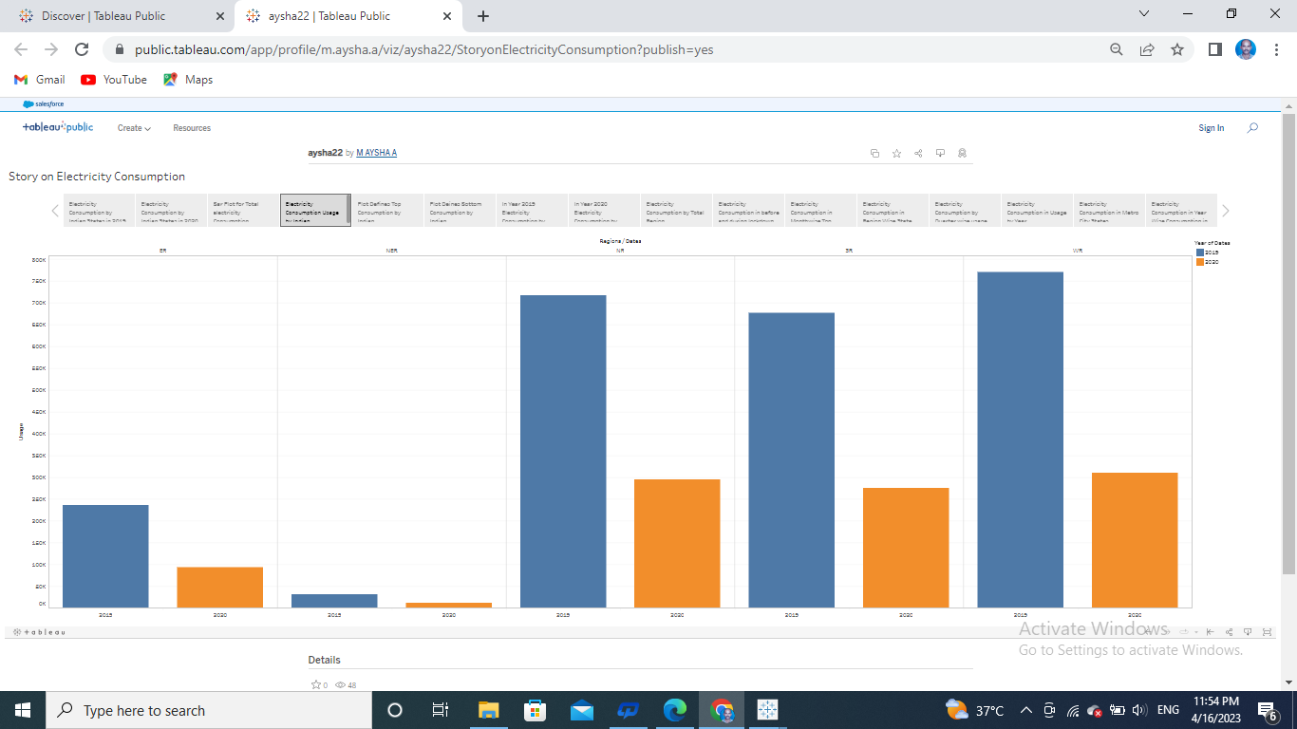

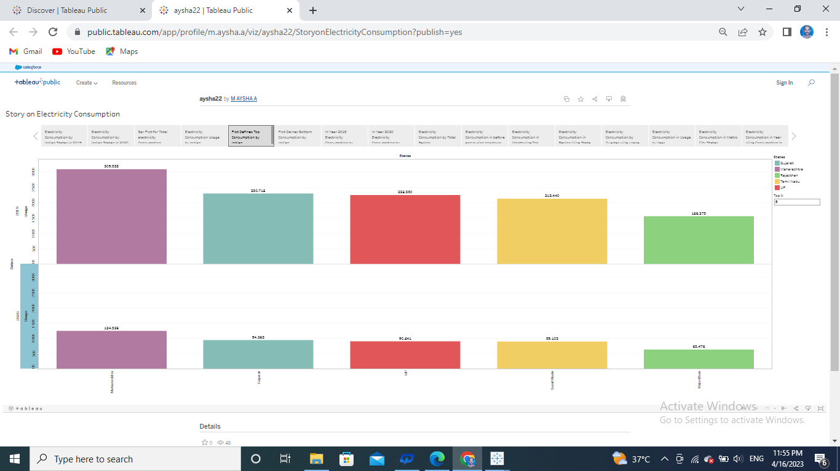

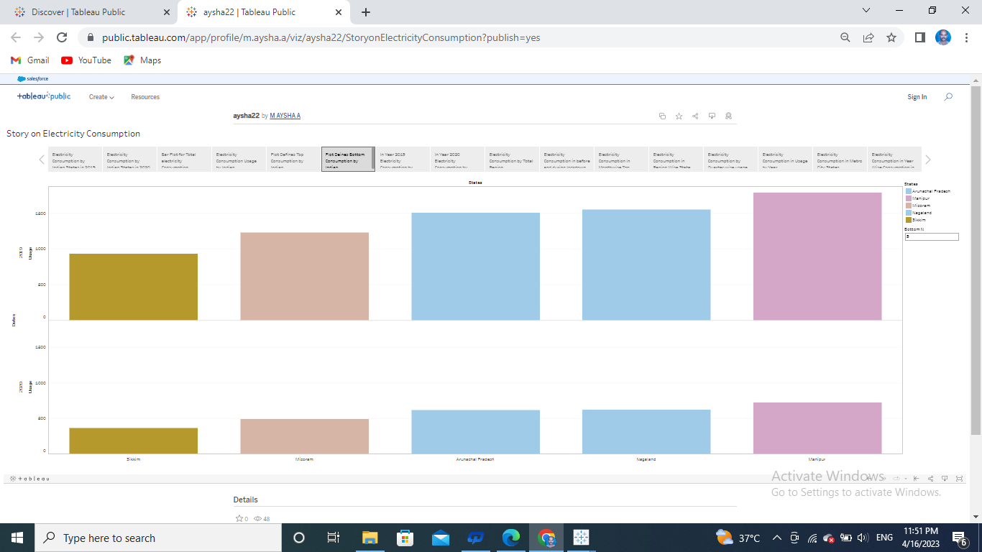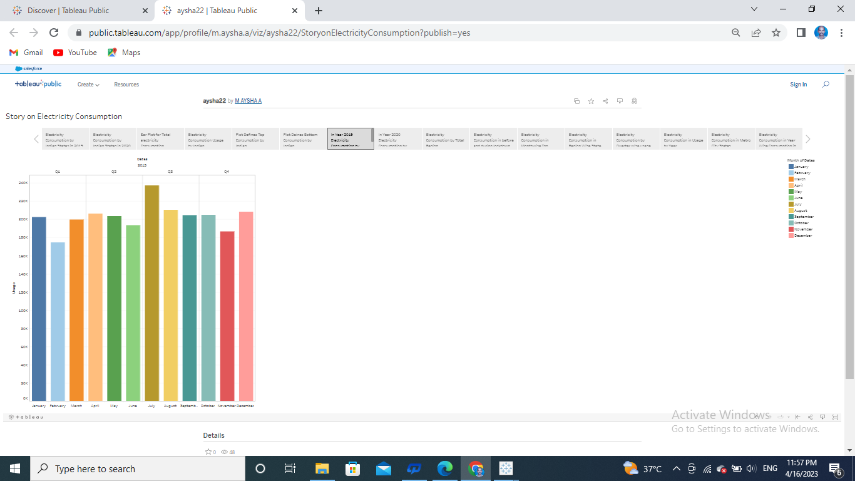

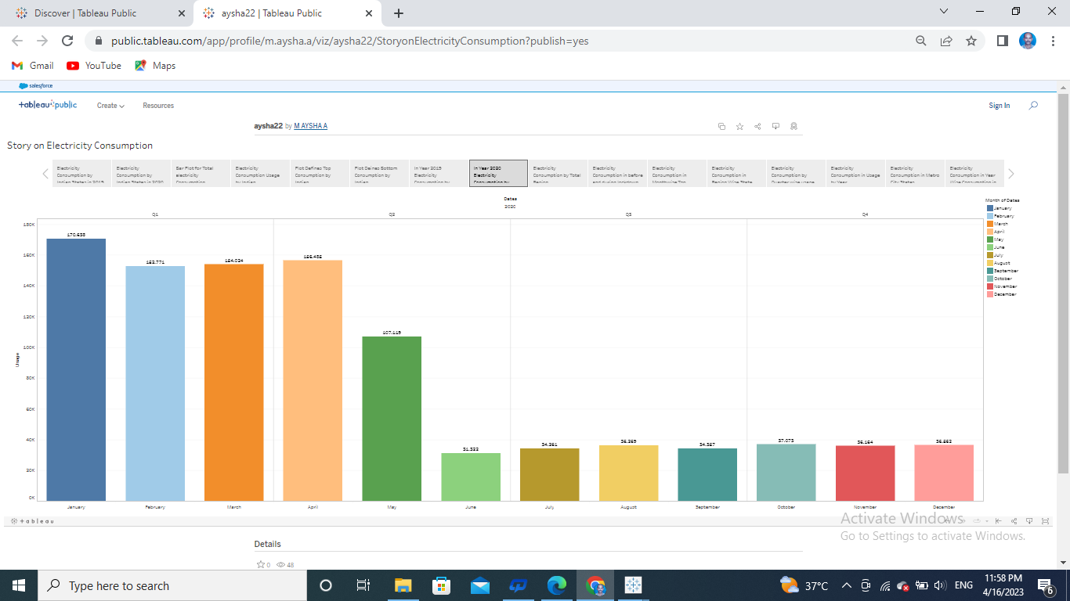

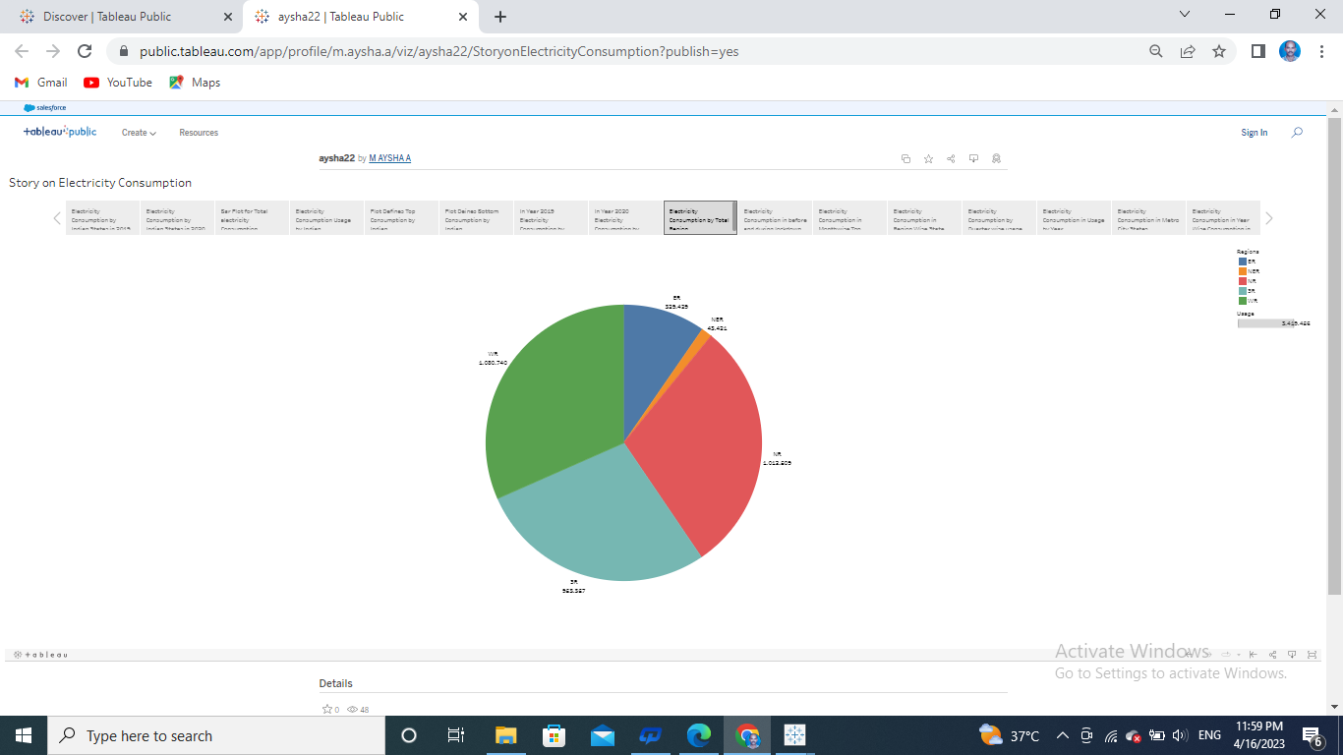

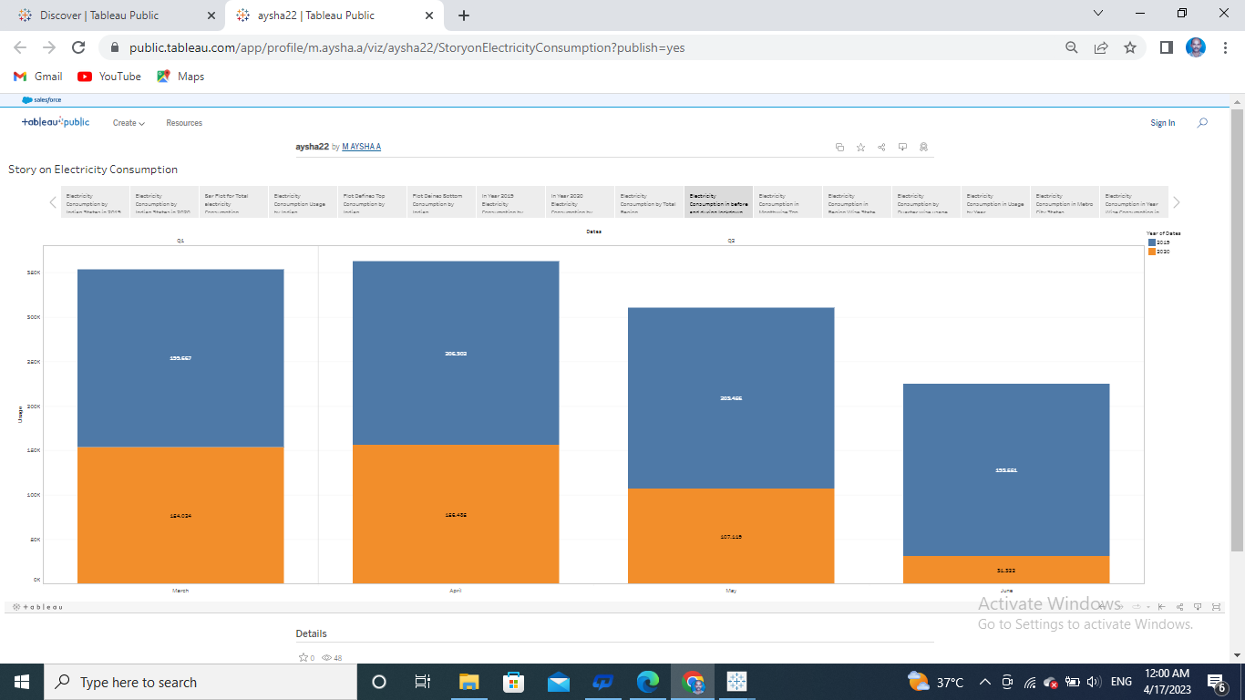

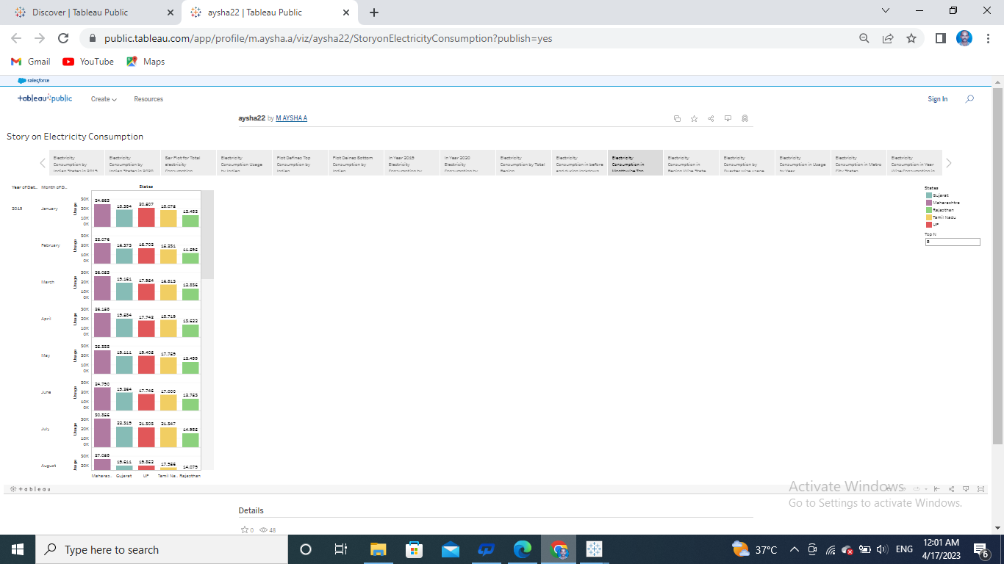

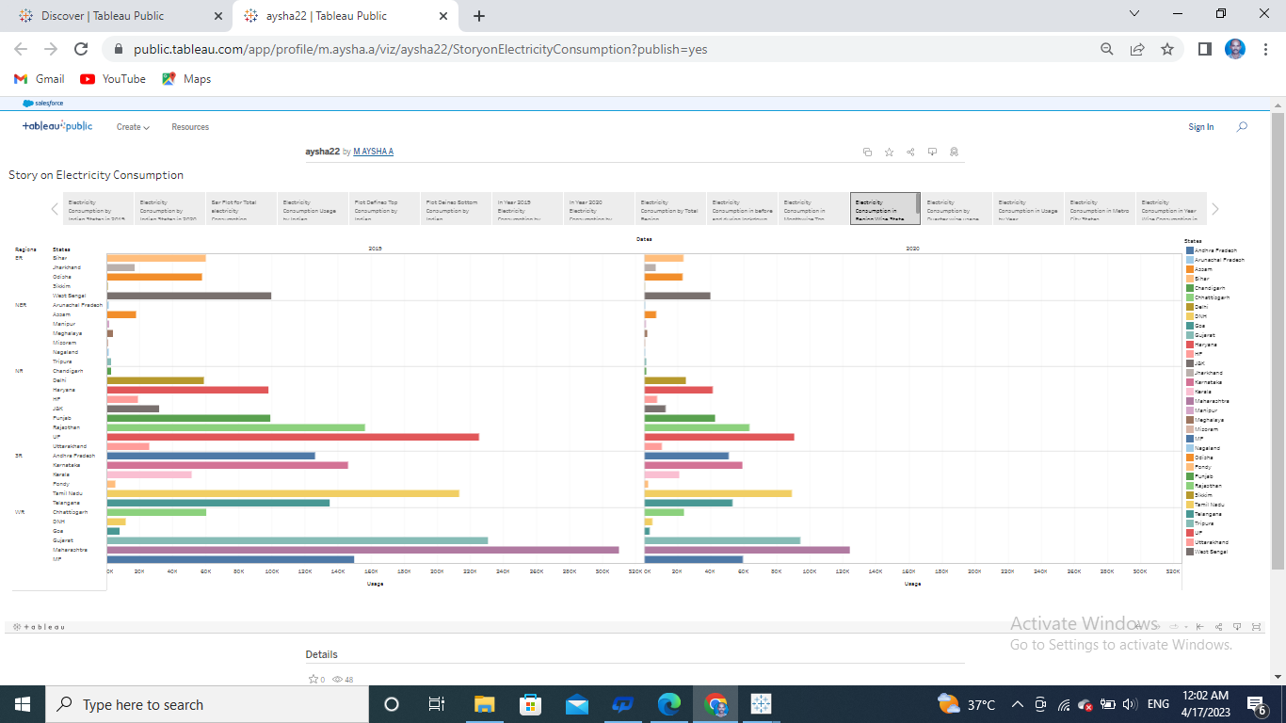

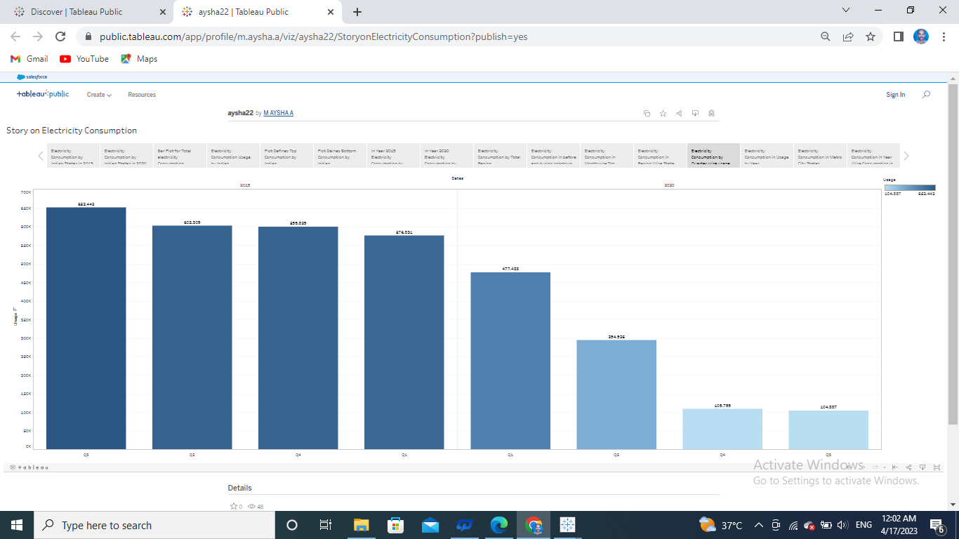

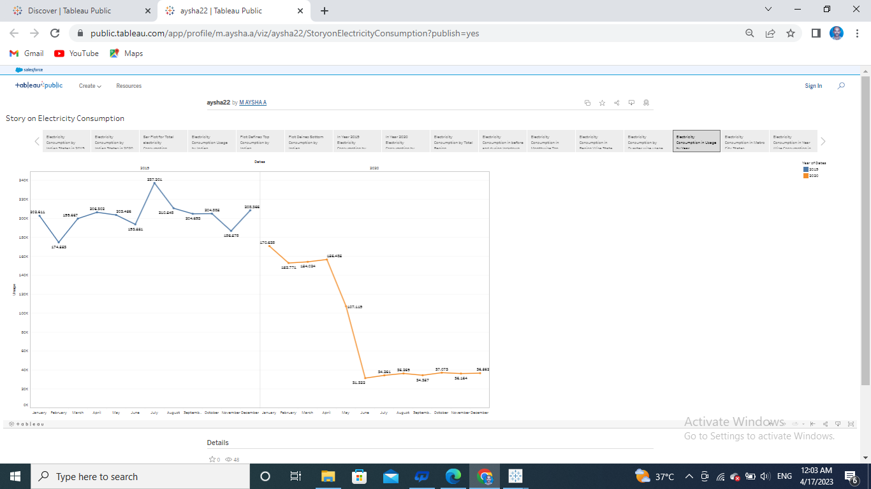

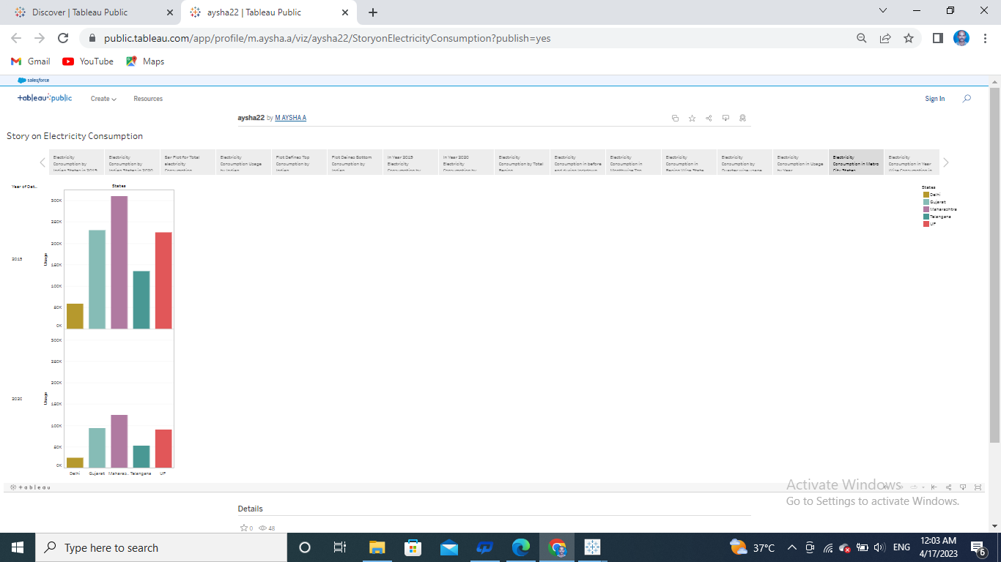

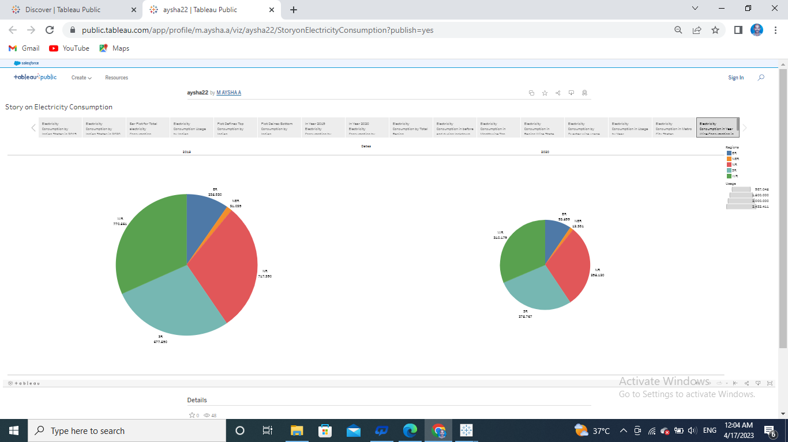

**4.ADVANTAGES**&**DISADVANTAGES**

Social Impact: By providing access to electricity, the analysis can help to improve the quality of life for people living in areas without access to electricity, including providing access to lighting, heating, and cooling, and powering essential services such as hospitals and schools..

Business Model/Impact: By understanding consumption patterns and trends, the analysis can help businesses identify market opportunities and develop strategies to meet the growing demand for electricity in India.

**5.APPLICATION**

The business requirements for analyzing analysis on electricity consumption in India Identify the current patterns of electricity consumption in different regions and sectors of India. This information can be used to identify areas where consumption is high and areas where it is low. Identify opportunities for improving energy efficiency and reducing consumption in different sectors and regions. This information can be used to develop policies and programs to promote energy efficiency. This information

**6.CONCLUSION**

We’ve successfully created and analyzed state wise, region wise and over all electricity consumption in India from Jan 2019 till 5th December 2020.This data is very useful to know the electricity consumption of India.

**7.FUTURE SCOPE**

In the stated policies scenario global electricity demand grows at 2.1% per year to 2040 twice the rate of primary energy demand.

This required electricity's share in total final energy consumption from 19% in 2018 to 24% in 2040.

Electricity demand growth is set to be particularly storing in developing economies.

**8.APPENDIX**

Sourcecode

**file:///C:/Users/dell/Downloads/Electricity%20Consumption%20Analysis/index.html**